**Networking**

Class --

**Lecture --**

**Subnetting**

**.**



**Lab Objectives:**

* IP Address
* Private address range.
* Subnetting.
* Benefits of subnetting.
* Practical examples.

**Ip Address**

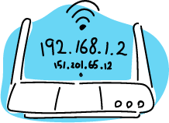

* ***An IP address is an address used to uniquely identify a device on an IP network.***
* ***The address is made up of 32 binary bits which can be divisible into a network portion and host portion with the help of a subnet mask.***
* ***32 binary bits are broken into four octets (1 octet = 8 bits)***
* ***Dotted decimal format (for example, 172.16.81.100)***

**Private Address Range**

|  |  |
| --- | --- |
| **Address Class** | **Reserved Address Space** |
| Class A | 10.0.0.0 - 10.255.255.255 |
| Class B | 172.16.0.0 - 172.31.255.255 |
| Class C | 192.168.0.0 - 192.168.255.255 |

**subnetting**

* ***Creates multiple logical networks that exist within a single Class A, B, or C network.***
* ***If you do not subnet, you will only be able to use one network from your Class A, B, or C network, which is unrealistic***
* ***Each data link on a network must have a unique network ID, with every node on that link being a member of the same network***

**Benefits of subnetting**

1. ***Reduced network traffic***
2. ***Optimized network performance***
3. ***Simplified management***
4. ***Facilitated spanning of large geographical distances***

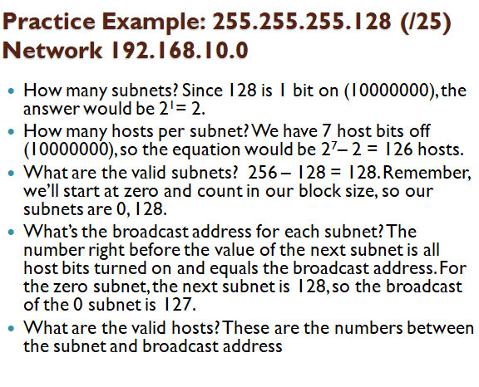

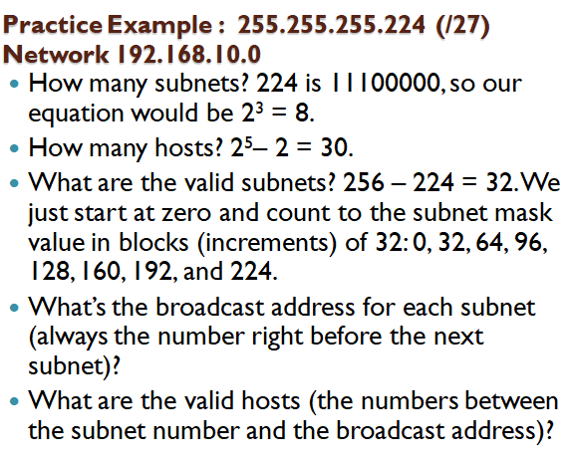

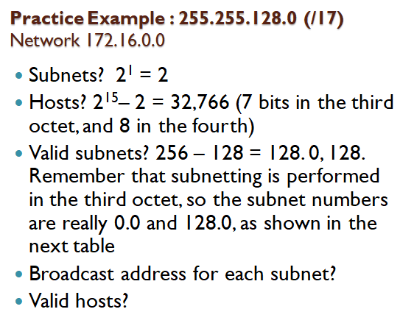

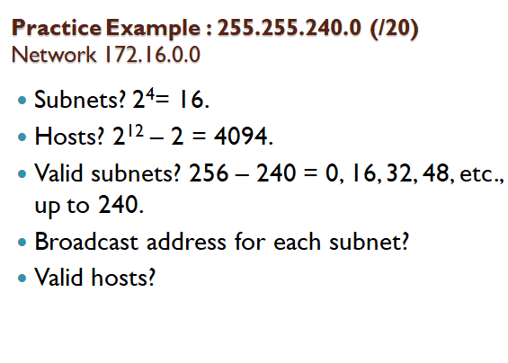



***End Of this slide***